**UNIVERSITY OF THE PUNJAB**

**GUJRANWALA CAMPUS**



**Department of Information Technology**

**Computer Vision**

**Assignment**

* **Submitted by:**

Hammad Bin Tariq

* **Session:**

BSIT 7th semester

* **Roll no:**

(BIT21203) Afternoon

* **Submitted to:**

Mam Fouqia Zafeer

**Topic:**

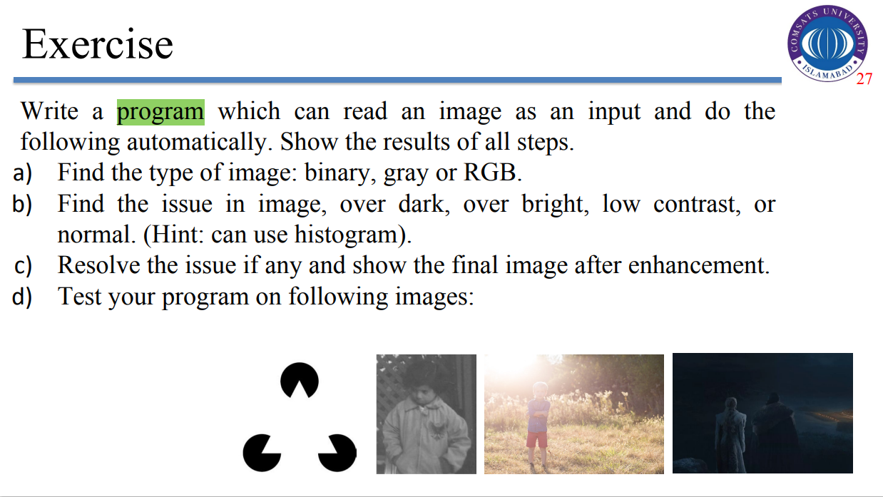

**MATLAB Code:**

% Read the input image

[file, path] = uigetfile({'*.png;*.jpg;*.jpeg'}, 'Select an Image');

image = imread(fullfile(path, file));

% Step 1: Detect Image Type (Binary, Grayscale, or RGB)

if ndims(image) == 3

disp('Image Type: RGB');

grayscale = rgb2gray(image); % Convert to grayscale for analysis

else

disp('Image Type: Grayscale');

grayscale = image;

end

% Check if the image is binary

if islogical(grayscale)

disp('Image Type: Binary');

end

% Step 2: Analyze the Issue (Histogram Analysis)

figure;

subplot(2, 3, 1);

imshow(image);

title('Original Image');

subplot(2, 3, 2);

imhist(grayscale);

title('Histogram');

% Determine image condition

mean_intensity = mean(grayscale(:));

if mean_intensity < 50

disp('Issue: Over Dark');

issue = 'dark';

elseif mean_intensity > 200

disp('Issue: Over Bright');

issue = 'bright';

elseif std(double(grayscale(:))) < 30

disp('Issue: Low Contrast');

issue = 'low_contrast';

else

disp('Image is Normal');

issue = 'normal';

end

% Step 3: Resolve the Issue

if strcmp(issue, 'dark')

% Apply Histogram Equalization

enhanced_image = histeq(grayscale);

elseif strcmp(issue, 'bright')

% Apply Gamma Correction

gamma = 0.4; % Reduce brightness

enhanced_image = uint8(255 * ((double(grayscale) / 255) .^ gamma));

elseif strcmp(issue, 'low_contrast')

% Apply Contrast Stretching

min_intensity = double(min(grayscale(:)));

max_intensity = double(max(grayscale(:)));

enhanced_image = uint8(255 * (double(grayscale) - min_intensity) / (max_intensity - min_intensity));

else

enhanced_image = grayscale; % No enhancement needed

end

% Step 4: Display the Enhanced Image

subplot(2, 3, 3);

imshow(enhanced_image);

title('Enhanced Image');

subplot(2, 3, 4);

imhist(enhanced_image);

title('Enhanced Histogram');

disp('Processing Complete.');

**First Output:**

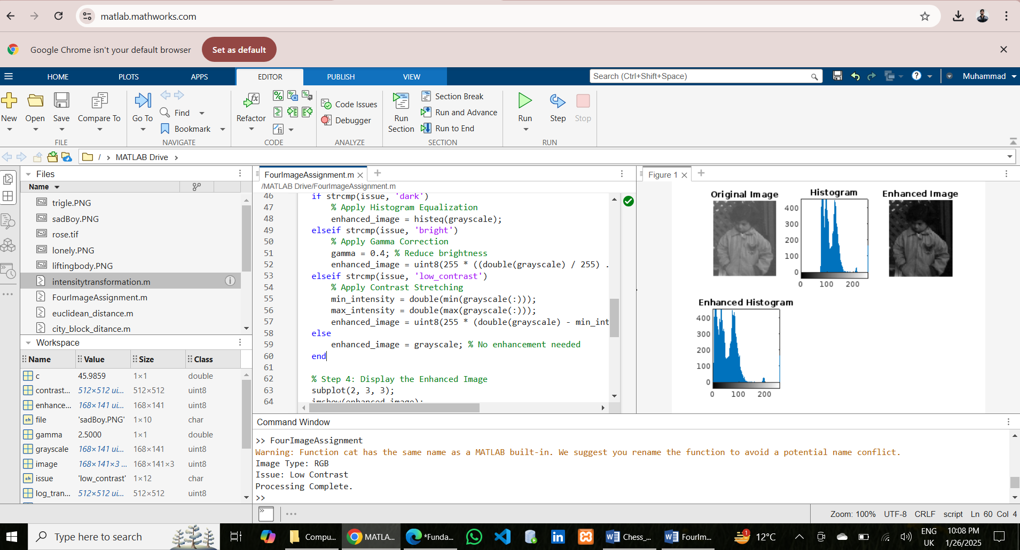

**Second Output:**

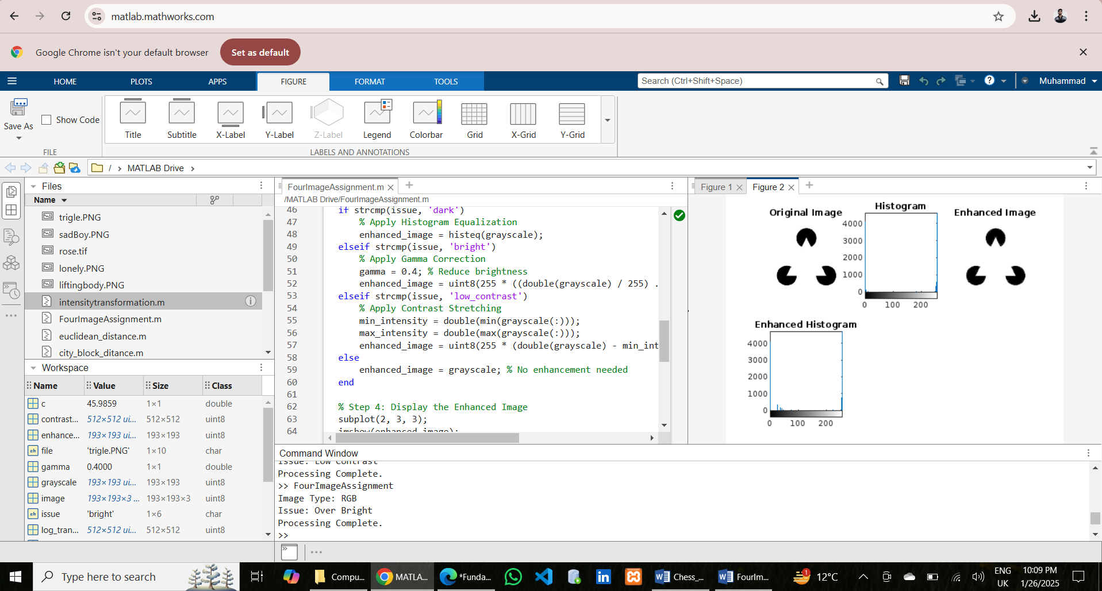

**Third Output:**

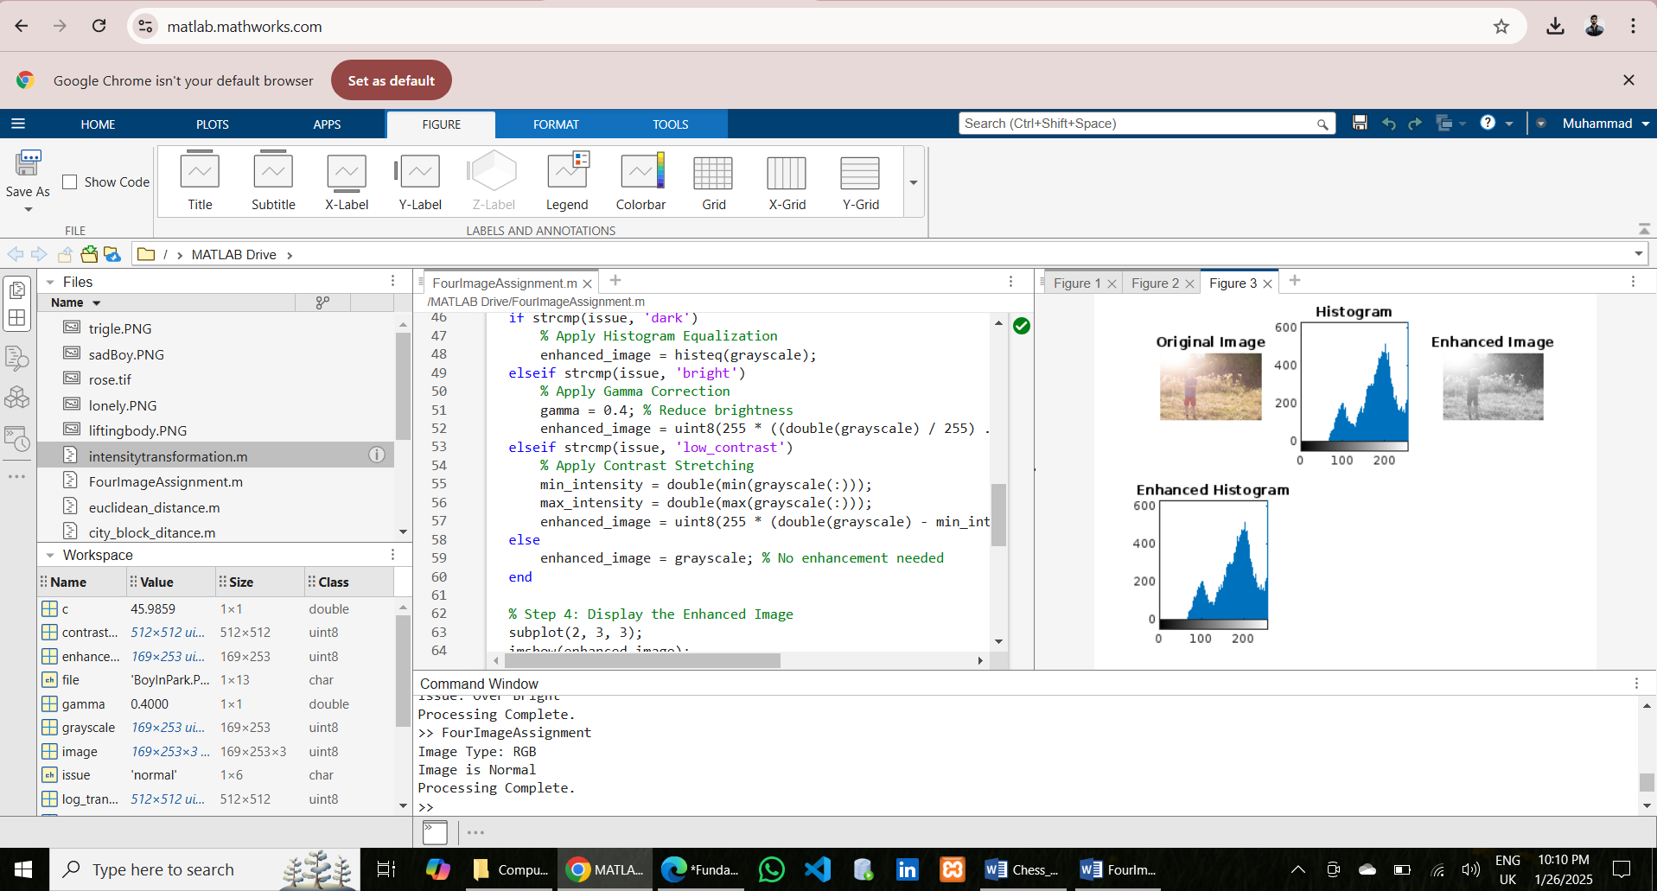

**Fourth Output:**

